Linda Sioux Henley, DRT, ADDA

(210) 382-2289

[sinapau@satx.rr.com](mailto:sinapau@satx.rr.com)

[www.lindasiouxhenley.com](http://www.lindasiouxhenley.com)

March 31, 2023

To Whom it May Concern:

I would like to introduce myself as an applicant for the Art Sculpture Project located in the Old Town Helotes traffic circle. Based on my experience in western art and bronze sculpture, I am confident that I am the artist for this job.

In 1982 I attended a sculpting workshop at the Cowboy Artist’s Museum in Kerrville, TX. This began my journey of sculpting which has led to so many great accomplishments. In 1990 I was commissioned by La Cantera Enterprises (operated and managed by Opryland in Nashville, TN) to create my first life-size bronze sculpture, the “Folklorico Dancer”, located at Six Flags Fiesta Texas.

In 1986 I became a member of the Daughters of the Republic of Texas for being a direct descendant of one of the oldest men who died defending the Alamo, Gordon C. Jennings. In 1998, I was commissioned by The Daughters of the Republic of Texas district VIII to design and create my second life-size bronze sculpture, “Texas Pioneer Woman”, to honor the early Texas pioneer women, which was placed on the Texas State Capitol grounds in Austin, TX.

In 2017 I completed my most recent life-size bronze sculpture, “Pecos Bill” located at the Chamber of Commerce in Pecos, TX. This is my interpretation of Pecos Bill, a fictional cowboy and folk hero from the story, The Legend of Pecos Bill.

Thank you for your time and consideration of my application. I feel that this project will allow me to utilize my well-practiced skills to add value to the City of Helotes.

Sincerely,

Linda Sioux Henley, DRT, ADDA

Attachments:

1. The Folklorico Dancer
2. Honoring Texas Pioneer Women
3. Pecos Bill

**The “Folklorico Dancer”**

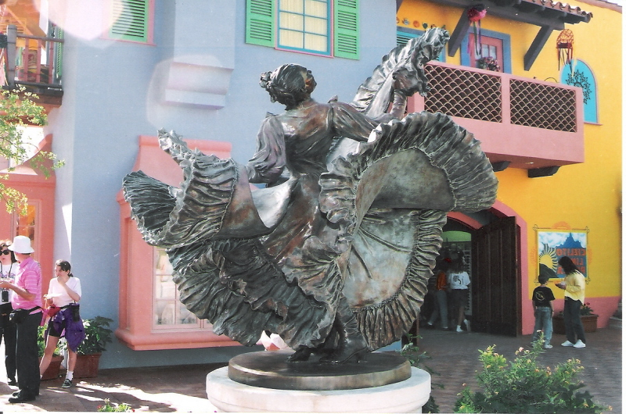

**“Texas Pioneer Woman”**

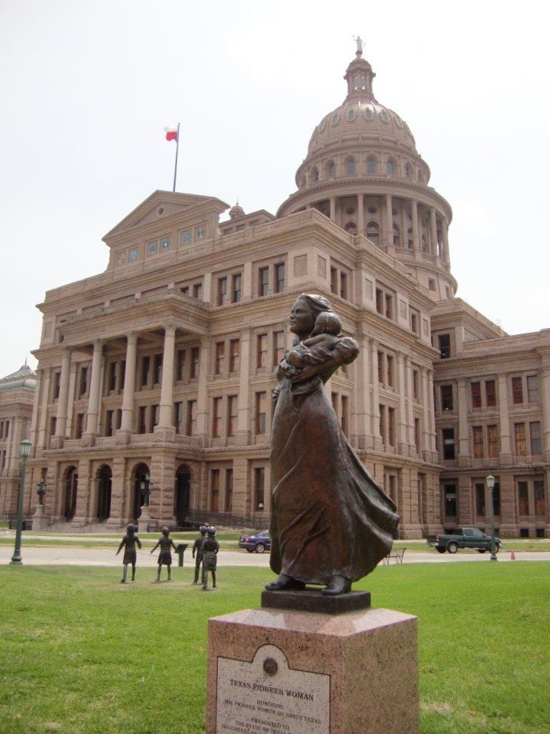

**“Pecos Bill”**

