Executive Summary for Old Town Jenny
Helotes Art Grant Program

Artist: Suzanne Edmonson
Project: Create an installment that is crowd pleasing, full of fun and encourages people to visit retail in the old town area.
Produce Imagery of Jenny, The Donkey on metal. Image of donkey head and sweatshirt double sided on metal post. Series of three to be temporarily installed near Old Town footbridge, near the sidewalk between B-Daddy’s BBQ and the medical building next to it or possibly near the public parking area and lastly, one near Helotes Gallery and Texas Grounds. Jenny’s sweatshirt to be printed in three different eye-catching colors with various logos on the sweatshirt, one could be of corn. Another, the local school panther mascot and a third that says howdy.
This theme could then be expanded by way of floor stickers of the Jenny head like the call-out image at the bottom to include retailer’s throughout Helotes thereby making a visual connection between the old town area and the newer township. Call-out stickers (in this case, removable floor stickers) could be printed at a low cost for special events and City promotions such as Free Sales Tax Day, Cornyvale, Christmas Tree Lighting, Giftcard Giveaway, etc. The call-out could even have a QR code on it to offer discounts and cross-advertising messaging for retail establishments. (NOTE: Sticker’s would be an expanded option and is not in the proposed estimate below).
Jenny brings a smile to everyone’s face. People will like taking photos with Jenny.
Project Estimate:
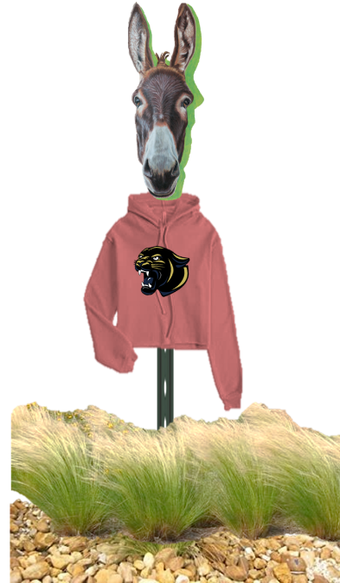
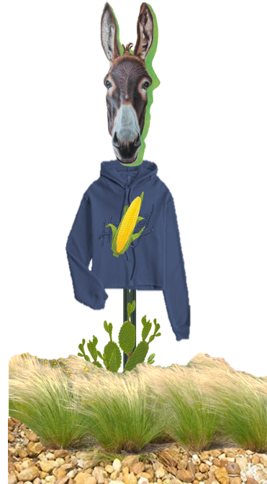
Sign Posts and Installation $ 700.00
Printed Images $ 504.00
Artist Fees $3500.00
TOTAL: $4,704.00
Examples:
